# Efficient Summaries with Custom Functions (Final Version)

This document includes the question, the solution, and a breakdown of the code provided in the screenshot.

## Uploaded Screenshot

Below is the screenshot of the task:

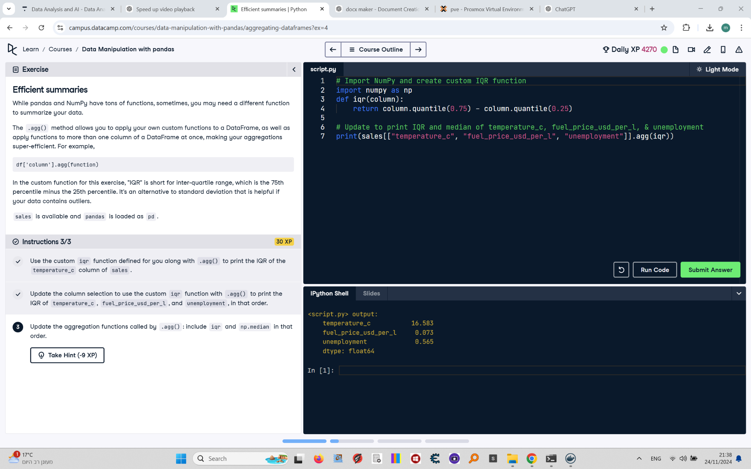

## Question

1. Use the custom `iqr` function defined for you along with `.agg()` to print the IQR of the `temperature_c` column of `sales`.  
2. Update the column selection to use the custom `iqr` function with `.agg()` to print the IQR of `temperature_c`, `fuel_price_usd_per_l`, and `unemployment`, in that order.  
3. Update the aggregation functions called by `.agg()`: include `iqr` and `np.median` in that order.

## Answer

# Import NumPy  
import numpy as np  
  
# A custom IQR function  
def iqr(column):  
 return column.quantile(0.75) - column.quantile(0.25)  
  
# Print IQR and median of temperature_c, fuel_price_usd_per_l, and unemployment  
print(sales[['temperature_c', 'fuel_price_usd_per_l', 'unemployment']].agg([iqr, np.median]))

## Code Explanation

# Explanation of the code:

1. `import numpy as np`: Imports the NumPy library, which is necessary to use the `np.median` function.

2. `def iqr(column):`: Defines a custom function `iqr` to calculate the interquartile range (IQR) of a column by subtracting the 25th percentile from the 75th percentile.

3. `sales[['temperature_c', 'fuel_price_usd_per_l', 'unemployment']].agg([iqr, np.median])`: Applies both the `iqr` and `np.median` aggregation functions to the selected columns (`temperature_c`, `fuel_price_usd_per_l`, and `unemployment`) in the `sales` DataFrame and prints the results in the specified order.